SIMATS ENGINEERING
ASSESSMENT TOOL 1
COURSE NAME: Computer Vision with OpenCV COURSE CODE: DSA02 COURSE OUTCOME COVERED
CO3: Analyze shape representation methods and techniques such as contours, regions, deformable models, and multi-resolution analysis. (BL4)
Assessment Tool Weightage: 50%
QUESTIONS: 5 Total Marks:50 Annexure A
EXPERIMENT
Code of Conduct:
I ____________________ (Name / Reg No) certify that this submission is my original work and that I have adhered to the guidelines specified for this assessment.
I understand that any violation of academic integrity rules will result in disciplinary action. Signature of the student:
RUBRICS FOR CALCULATION
Criteria | Weight  age | Level 4 – Exemplary | Level 3 – Proficient | Level 2 – Developing | Level 1 –  Beginning | Marks
Understandi ng of  Concepts | 25 | Demonstrates thorough understanding and  effectively integrates  multiple  concepts/technologies | Good understanding with proper integration of  most concepts | Basic understanding; limited or partial  integration | Poor  understanding;  unable to integrate concepts
Experiment al Design | 30 | Well-planned, systematic implementation with  optimal solution | Correct implementation with minor issues | Basic implementation with errors or  inefficiencies | Incorrect or  incomplete  implementation
Use of  Tools | 20 | Effective and advanced use of tools/technologies with proper configuration | Appropriate use of tools with correct execution | Limited or inconsistent use of tools | Incorrect or  minimal use of  tools
Analysis of Results | 15 | Insightful analysis with accurate interpretation and validation of results | Good analysis with  reasonable interpretation | Basic analysis with  limited insights | Poor or incorrect analysis of results
Documentat ion | 10 | Clear, well-structured  documentation with  diagrams, code, and results | Organized  documentation with  necessary details | Basic documentation with missing details | Poor or  incomplete  documentation

Annexure A
EXPERIMENT
Experiment 1: Contour-Based Representation & Fourier Descriptors Scenario: Represent 2D shapes using contours and Fourier descriptors. Input Data:
A. Binary images of 2D hand-drawn letters (A–Z) or simple symbols (triangle, square, star)
B. Image size: 256 × 256 pixels
C. File format: PNG or BMP
Aim
To represent 2D shapes using contours and Fourier descriptors.
Input
- Binary image of letters A–Z or symbols
- Size: 256 × 256
- Format: PNG/BMP
2. Objective
The main objectives are:.
Python program

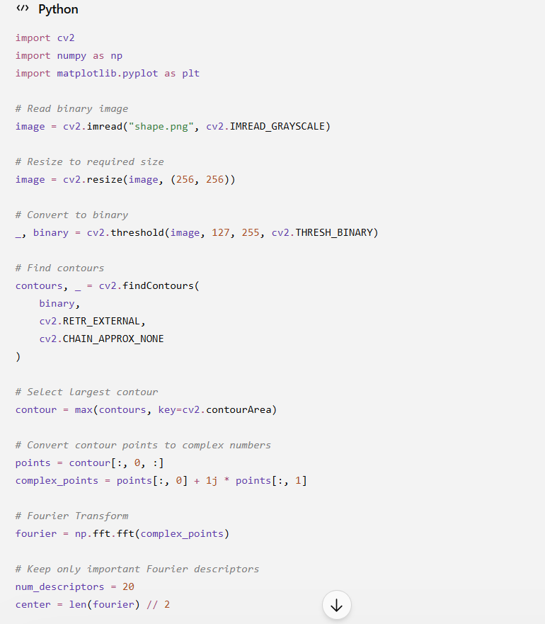
Expected Output
You will get:
- Original binary shape
- Contour reconstructed using Fourier descriptors
For example:
Input: triangle.png
Original Binary Shape Fourier Reconstruction
/ \ / \
/ \ / \
/_____\ /_____\
Result
The 2D shape is successfully represented using its contour and Fourier descriptors.
Out Put
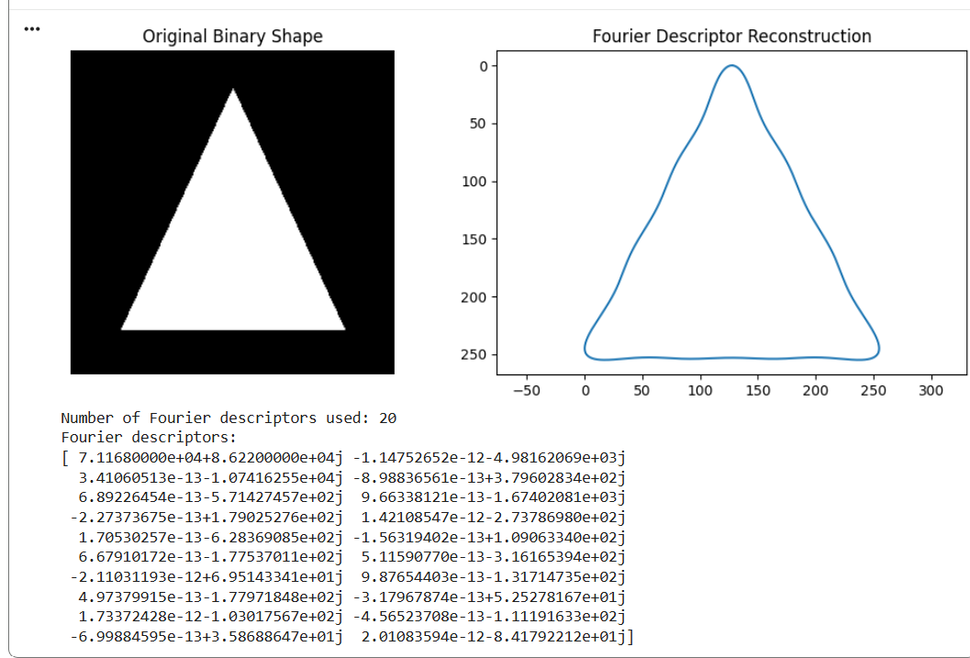

Experiment 2: Region-Based Representation & Medial Axis Scenario: Analyze object shapes in binary images using medial axis. Input Data:
A. Binary images of industrial components (e.g., gears, machine parts) B. Image size: 512 × 512 pixels
C. Defects like small holes, protrusions, or missing parts included D. File format: PNG
Aim
To analyze object shapes in binary industrial images using the medial axis.
Input
- Industrial component such as gear/machine part
- 512 × 512 pixels
- PNG
- Small holes, protrusions or missing parts
2. Objective
The main objectives are:
- To read a binary image containing a 2D shape.
- To detect the boundary or contour of the shape.
- To represent contour points using complex numbers.
- To apply the Discrete Fourier Transform (DFT).
- To extract Fourier descriptors from the contour.
- To reconstruct the original shape using selected descriptors.
- To understand how Fourier descriptors can be used for shape representation and recognition

Python Program
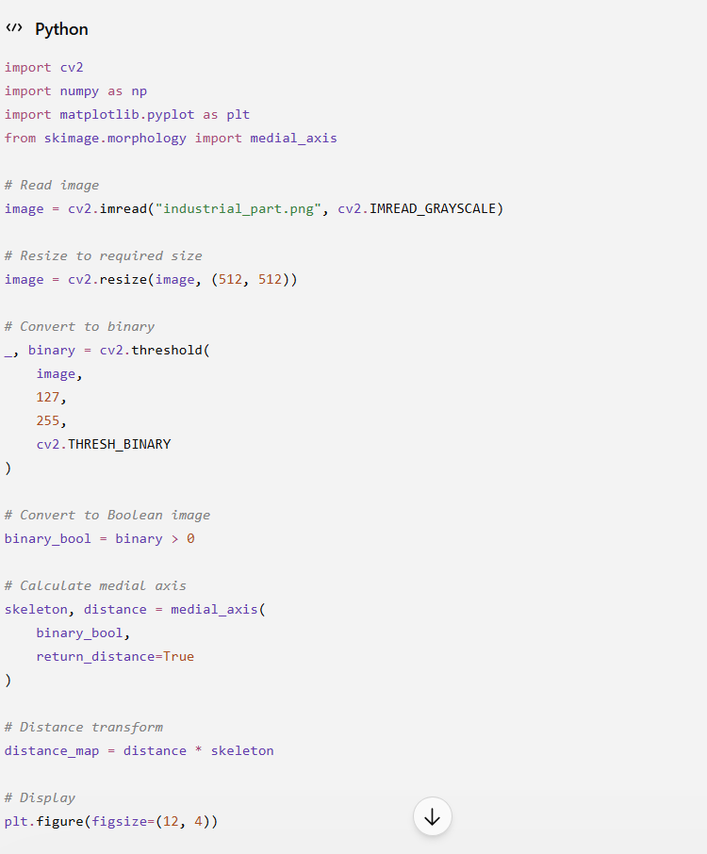
. Expected Output
The output contains:
- Original industrial component
- Binary representation
- Skeleton/medial axis
The medial axis appears along the central structure of the object.
Out Put
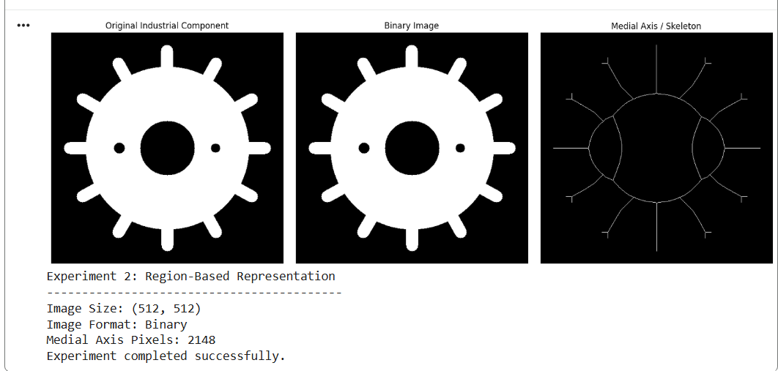

9. Applications
Medial-axis representation is used in:
- Industrial quality inspection
- Mechanical component analysis
- Character recognition
- Object skeletonization
- Medical image analysis
- Shape matching
- Robot vision
- Defect detection
10. Result
Thus, the industrial component was successfully converted into a binary representation and its medial axis/skeleton was extracted for structural analysis.

Experiment 3: Deformable Curves and Snakes (Active Contours) Scenario: Segment organs or objects with irregular boundaries. Input Data:
A. Grayscale medical images (e.g., liver or heart slices)
B. Image size: 512 × 512 pixels
C. Noise: mild Gaussian noise
D. File format: DICOM or PNG
1. Aim
To segment objects with irregular boundaries in grayscale medical images using deformable curves or active contour models (snakes).
2. Objective
The objectives are:
- To read a grayscale medical image.
- To introduce mild Gaussian noise.
- To smooth the image.
- To define an initial contour.
- To evolve the contour toward the object boundary.
- To obtain the final segmented boundary.
3. Input Data
The input is a grayscale medical image.
Input specifications:
- Example: Liver or heart slice
- Image size: 512 × 512 pixels
- Format: PNG or DICOM
- Noise: Mild Gaussian noise
- Image type: Grayscale

Program
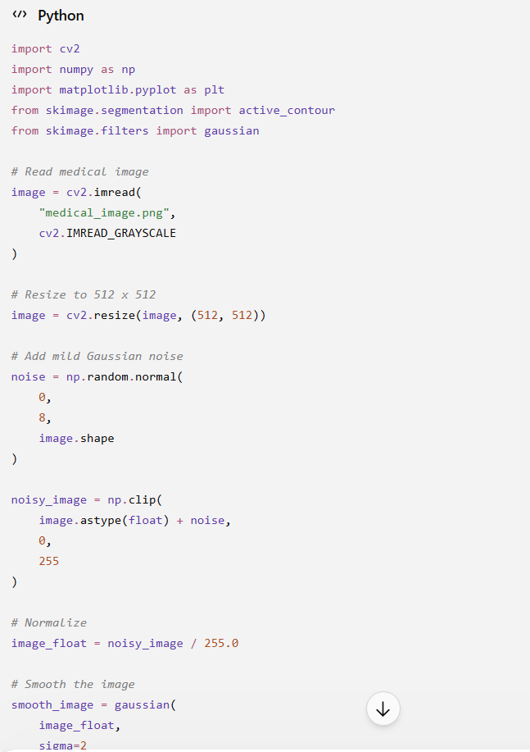
8. Expected Output
The output displays:
- Medical image with mild noise
- Initial contour
- Final contour
The final snake should move toward the boundary of the selected object.
Out Put
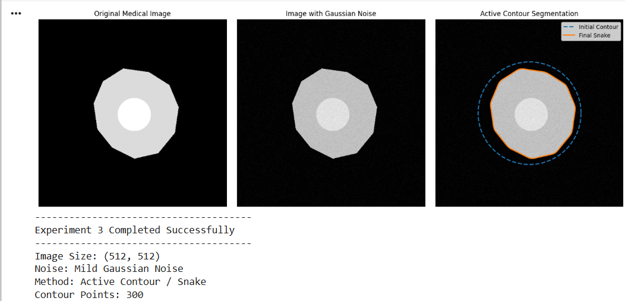
Applications
Active contours are used in:
- Medical image segmentation
- Tumor boundary detection
- Liver segmentation
- Heart segmentation
- Brain image analysis
- Object tracking
- Computer vision
- Image-based measurement

Experiment 4: Level Set Methods
Scenario: Track moving objects with evolving boundaries.
Input Data:
A. Video sequence (30 frames) of a moving object (e.g., a bouncing ball or moving hand)
B. Resolution: 640 × 480 pixels
C. Format: MP4 or sequence of PNG images
1. Aim
To track a moving object's boundary in a video sequence using the level set method.
2. Objective
The objectives are:
- To read a video sequence.
- To process individual frames.
- To convert frames into grayscale.
- To obtain an initial object region.
- To apply level set evolution.
- To track the changing boundary of the object.
- To visualize the boundary over multiple frames.
3. Input Data
The input is a video sequence containing a moving object.
Input specifications:
- Object: Bouncing ball or moving hand
- Number of frames: 30
- Resolution: 640 × 480 pixels
- Format:
  - MP4, or
  - Sequence of PNG images
Program
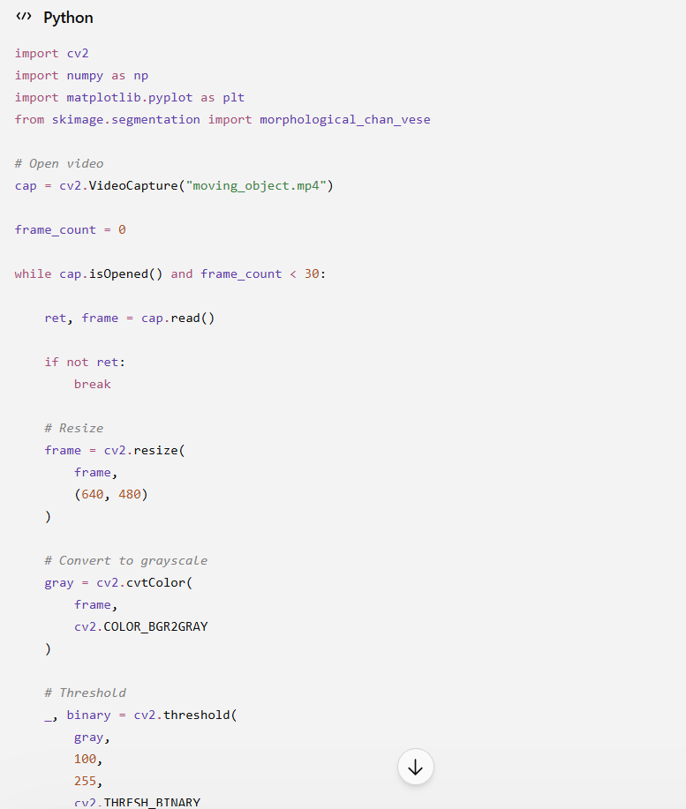
Expected Output
The program processes up to 30 frames.
Example:
Frame 1
↓
Frame 5
↓
Frame 10
↓
Frame 15
↓
Frame 20
↓
Frame 25
↓
Frame 30
Out Put
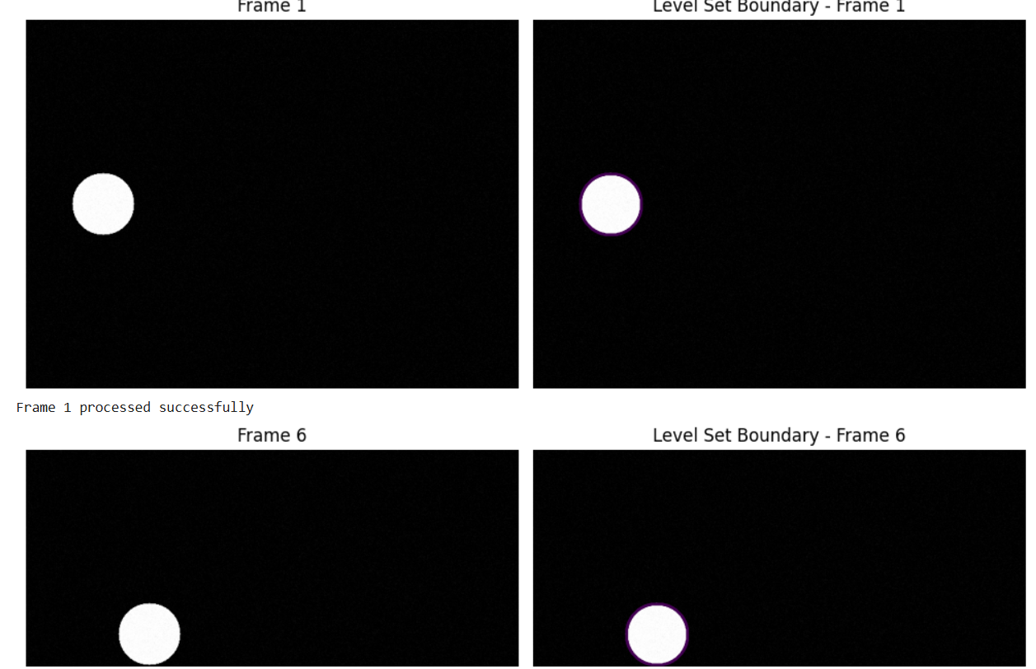

Experiment 5: Multi-Resolution & Wavelet Descriptors
Scenario: Shape recognition at multiple scales.
Input Data:
A. Grayscale images of objects at different scales (e.g., leaves, mechanical parts, coins)
B. Image sizes: 128 × 128, 256 × 256, 512 × 512 pixels
C. Format: PNG
Aim
To analyze and represent object shapes at different scales using multi-resolution analysis and wavelet descriptors.
2. Objective
The objectives of this experiment are:
- To read a grayscale object image.
- To resize the image to different resolutions.
- To perform multi-resolution analysis.
- To apply the 2D Discrete Wavelet Transform (DWT).
- To separate the image into low- and high-frequency components.
- To extract wavelet-based descriptors.
- To compare the object representation at different scales.
3. Input Data
The input consists of grayscale images of objects such as:
- Leaves
- Coins
- Mechanical components
- Simple shapes

Program
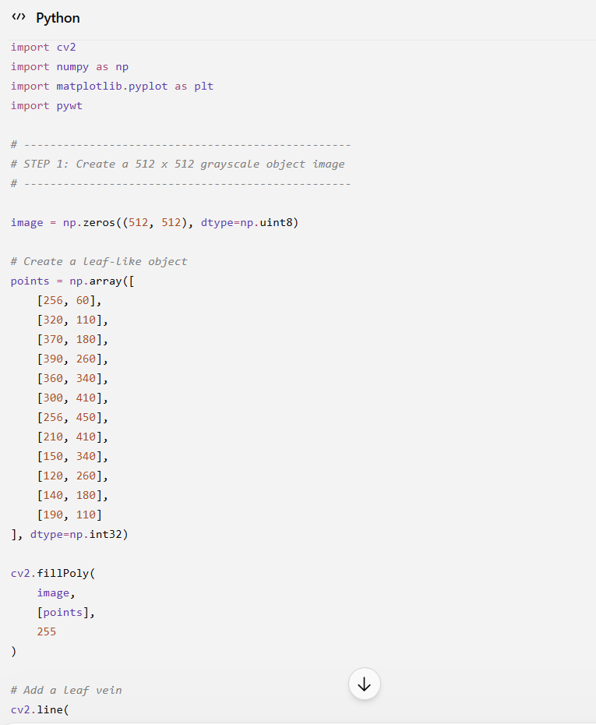
Expected Output
The program produces three main types of output.
Output 1: Multi-Resolution Images
You will see:
128 × 128 256 × 256 512 × 512
↓ ↓ ↓
Small Medium Large
resolution resolution resolution
The object remains recognizable at all three resolutions.
Output 2: Wavelet Decomposition
For every resolution, four components are displayed:
LL LH HL HH
↓ ↓ ↓ ↓
Main Horizontal Vertical Diagonal
shape details details details
Output 3: Descriptor Values
The program prints values similar to:
========================================
WAVELET DESCRIPTORS
========================================

Resolution: 128 x 128

Mean LL: ...
Std LL : ...
Mean LH: ...
Std LH : ...
Mean HL: ...
Std HL : ...
Mean HH: ...
Std HH : ...

Descriptor Vector:
[...]
Out Put
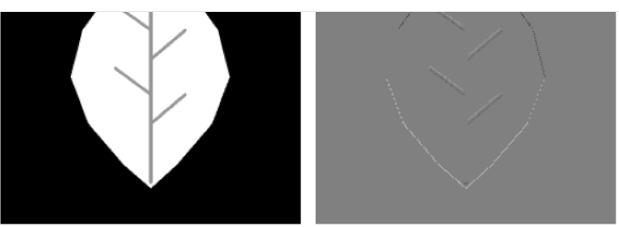
Result
The grayscale object was successfully represented at 128 × 128, 256 × 256, and 512 × 512 resolutions. The 2D Haar Wavelet Transform was applied successfully, and the LL, LH, HL, and HH components were obtained. Wavelet descriptors were extracted from the different resolution levels for multi-scale shape analysis.

